19th September 2019
Technical Bulletin Tech077
Full Distribution

Dear Customer,

BulletinTech077
Replacing turbo 789500-5017S as used on FPT applications
The production of turbo 789500-5017S has finished and it will be replaced by 841805-5006S which has a different oil inlet configuration.
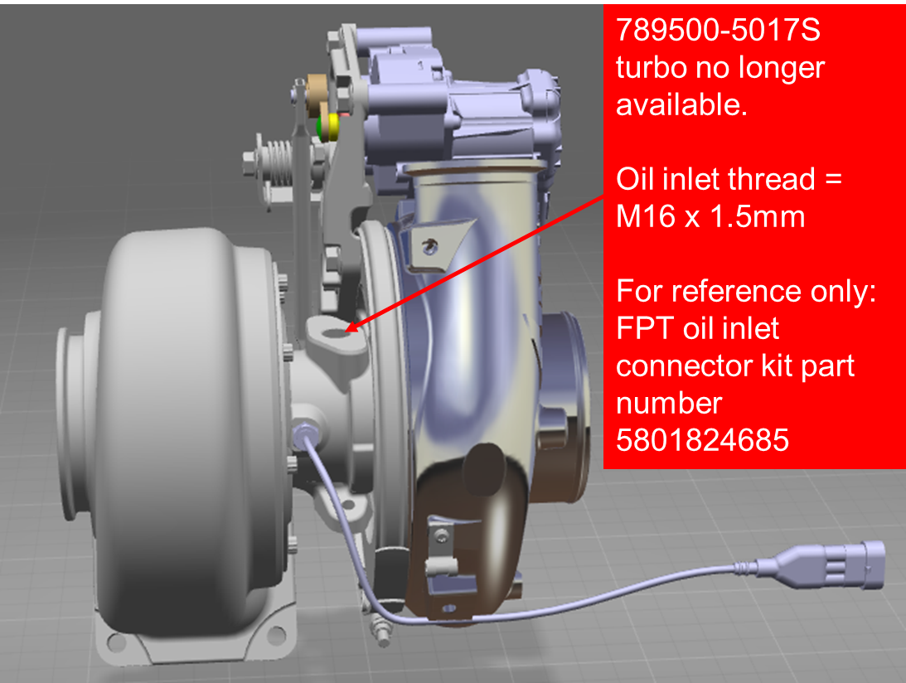
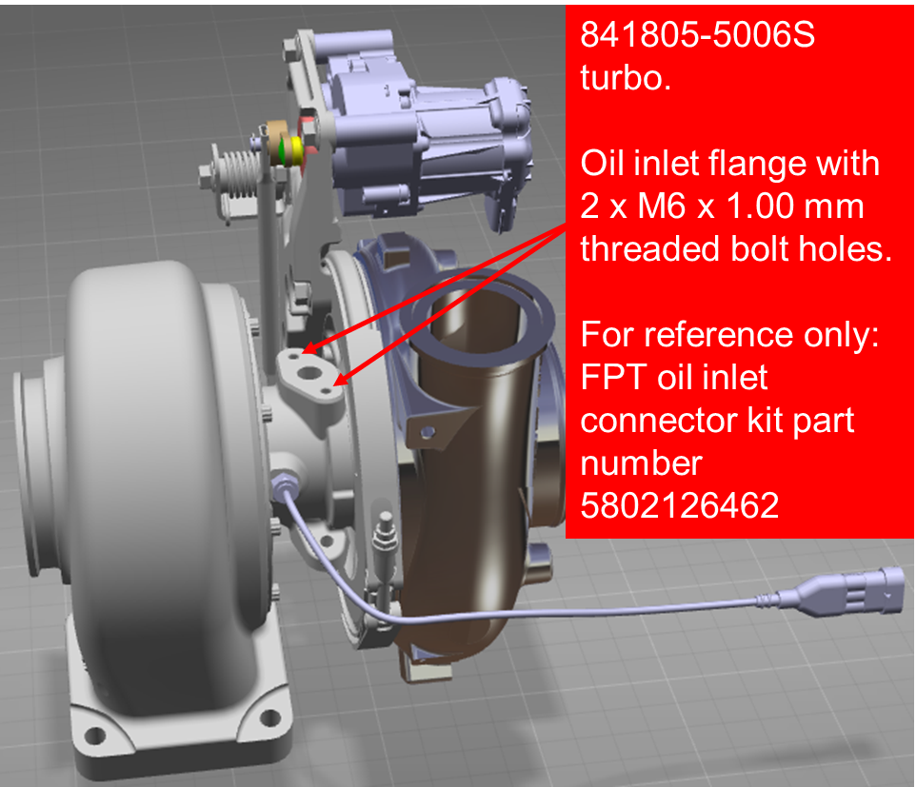
This means that to replace 789500-5017S it is necessary to also replace the oil inlet pipe kit which is an OEM part. See information below:

Note: drawings above are for oil inlet flange reference only. Housings orientations are not correct to specific part numbers.

Please pass this information to every customer purchasing these turbos from you.

Please distribute this information to all in your company who may need it.

Best Regards,
Trevor Cass
IAM Senior Technical support Specialist
Garrett – Advancing Motion

